Tracking Attendance through InsideCBU

Editing Attendance

- Navigate to the Attendance section of InsideCBU, under Academics. (refer to the Recording Attendance training document for details)
- Click on the class date (See Below).
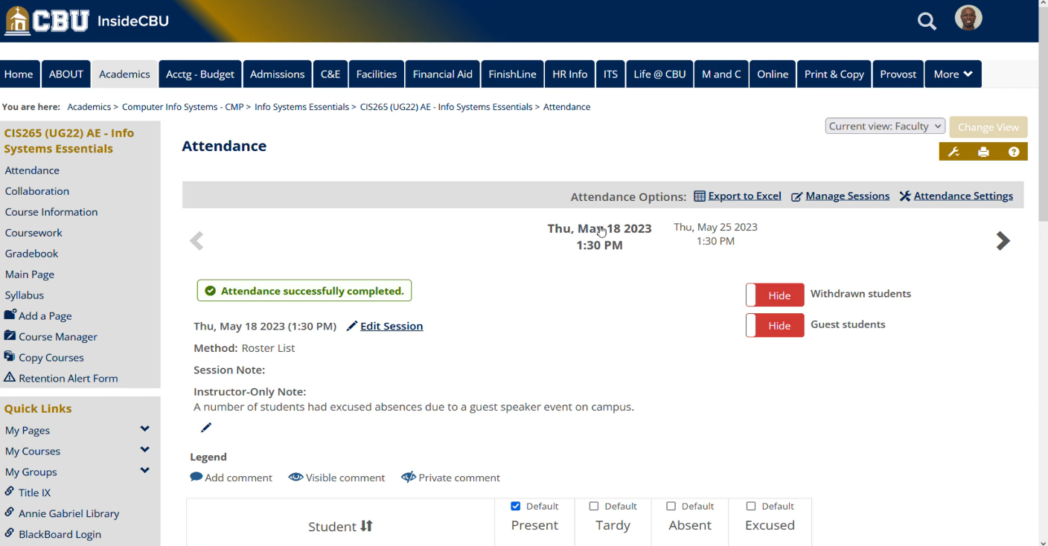
- Scroll to the lower half of the page and find the student that you wish to edit attendance for. Simply click the preferred selection to change the type of absence.
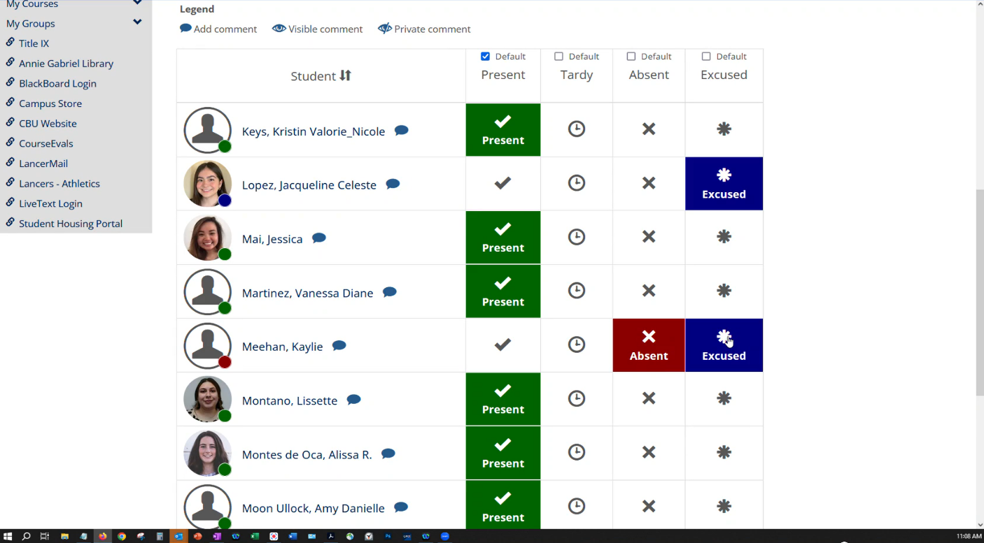

NOTE: See Attendance – Getting Started training document to learn how to navigate to the Attendance features in InsideCBU.

