Tracking Attendance through InsideCBU - Adding and Managing a Session

Add a Session

- If the course you teach is an independent study, directed study, or private instruction course, you will not have preset dates listed for your attendance throughout the semester.
- You will need to add sessions for each week. Multiple dates per week are not necessary unless you want to track each meeting time with student.
- For private instruction, it is suggested you just set up ONE meeting date per week and track ALL students taught within that week on that date. (i.e., You teach Sallie on Monday and Joey on Wednesday; however, you have FRIDAYS set as your teaching “date” in the system for each week and mark Sallie & Joey as “present” on the Friday date if they came to their lesson during that week.)
Add A Session

- Navigate to the Attendance link within InsideCBU, under Academics. (refer to the Recording Attendance training document for details)
- Click the Manage Sessions link (See Below)
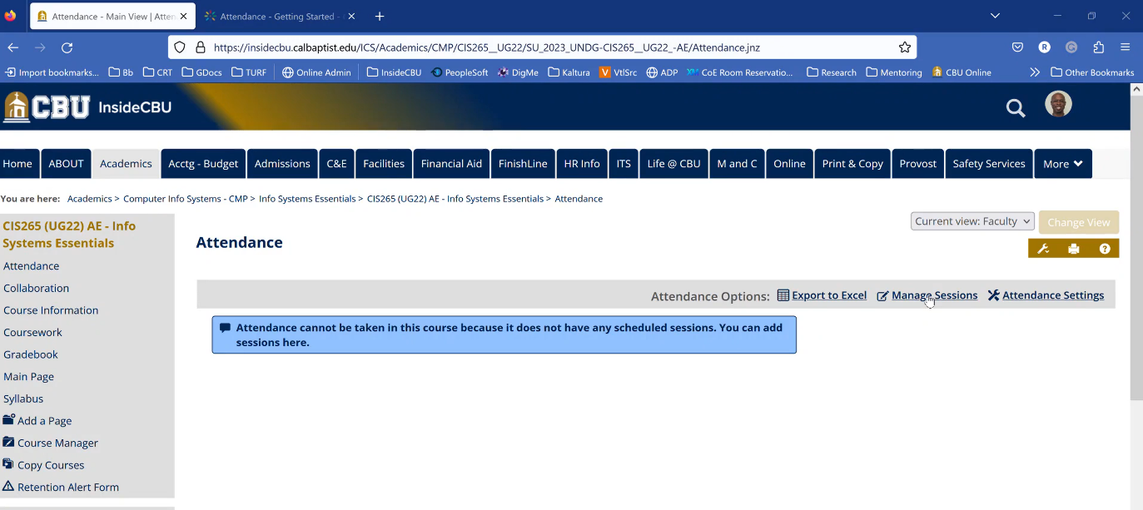
- Click the Add Session button (See Below)
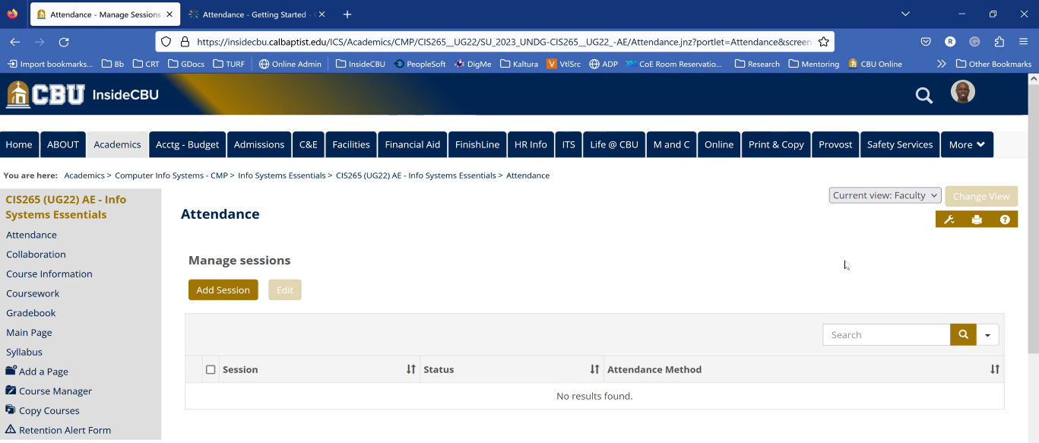
- Keep the mode in Roster List- Default (See below).
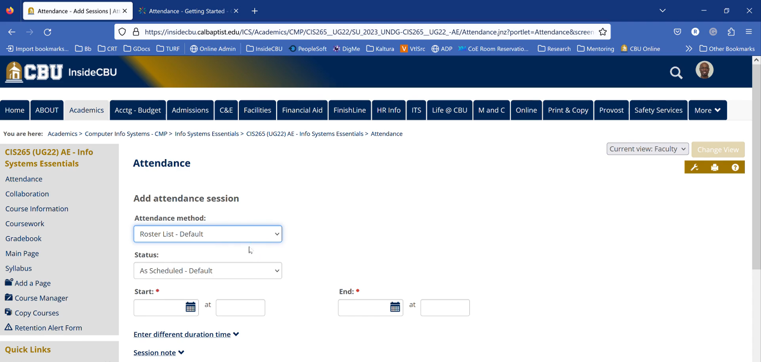
- To start a session, click the Blue Calendar in the text box under the word Start with a Red Asterisk. Upon clicking the calendar, an interactive calendar will appear. Click on the box representing the day the session will take place and the day will populate in the start text box (See Images 1 and 2 Below).
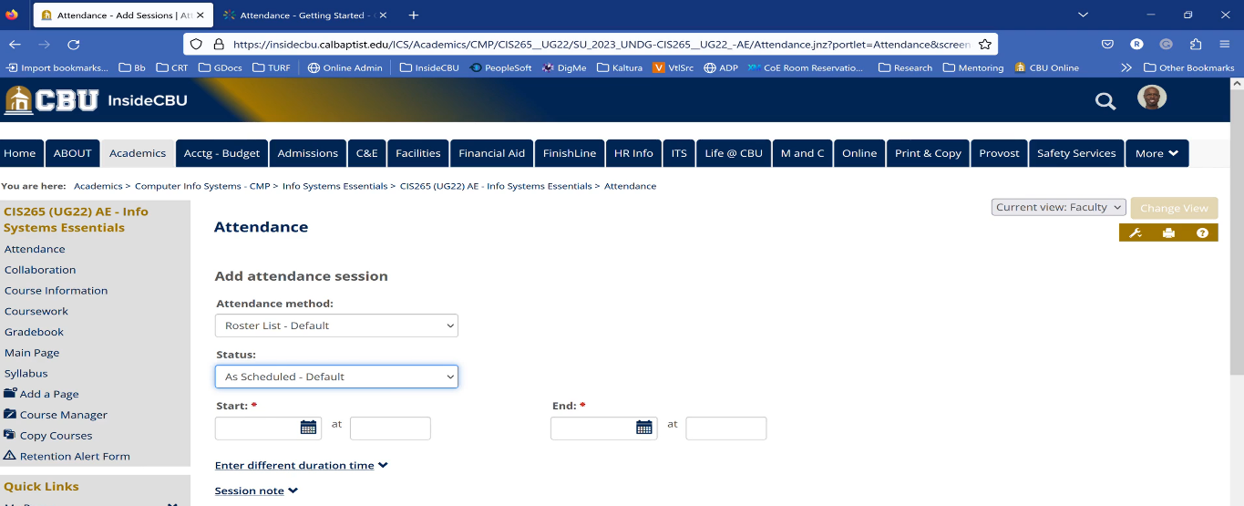

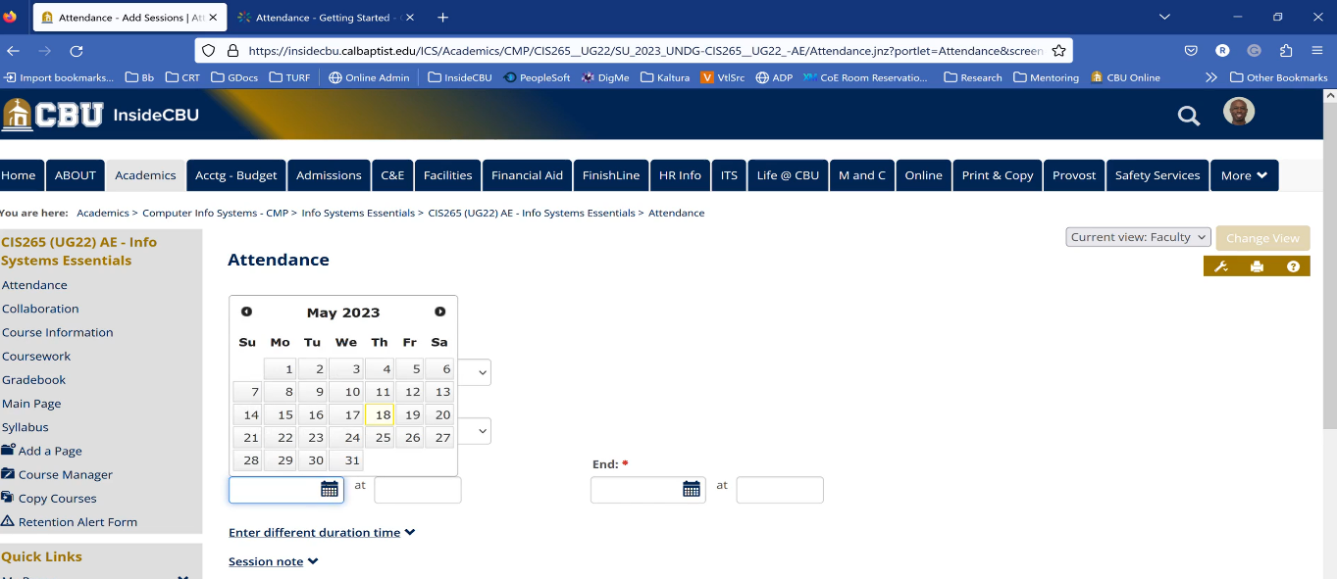

- Enter exact start and end times in the Start and End Text Boxes, the boxes next to the text box with the blue calendar (See Image 2 Above from Step 10).

- To customize the time length for a session, click Enter Different Duration Time and type the length of time in the text box in minutes (See Below).
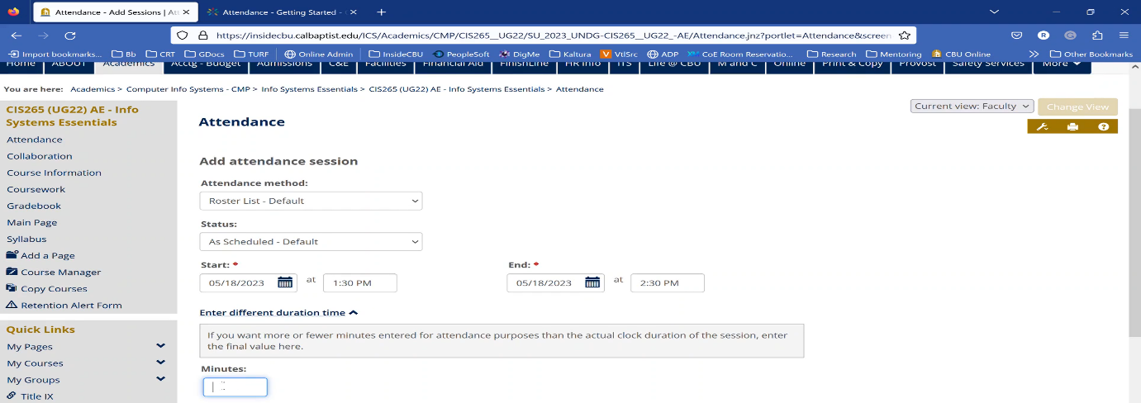
- Click on Session Note to create custom notes for each session (See Below) (*Note: Clicking multiple sessions will make the notes here the same for each session. Click on each session individually to change each session note for each individual session). 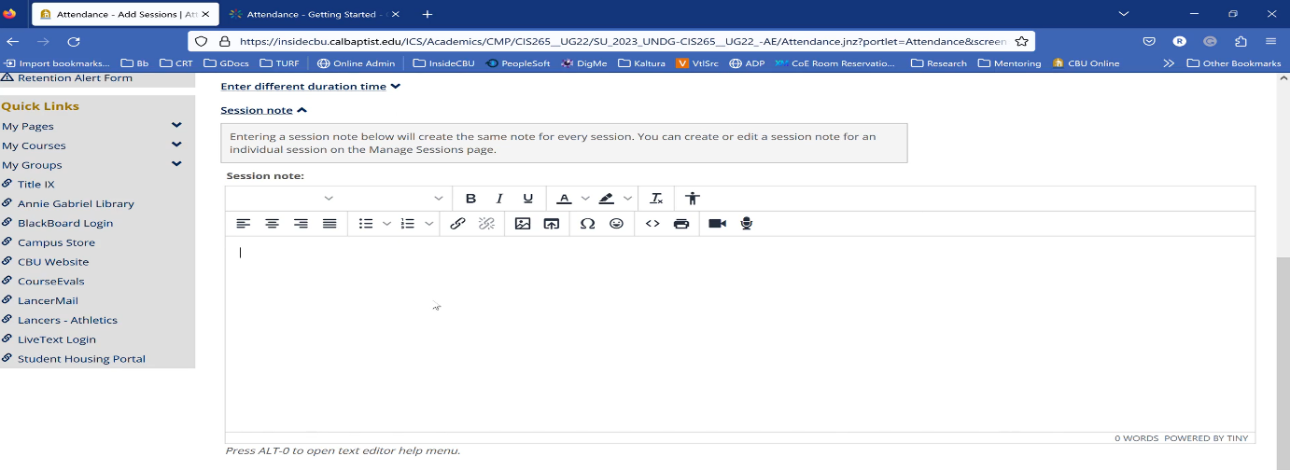

- Click on Multiple Sections to generate multiple sections simultaneously. You can select from Days, Weekdays, Weeks, and Months through a specific date, and they will generate. For example, one session can be generated once a week from May 18th until June 1st (See Below). Click Save when you are finished.
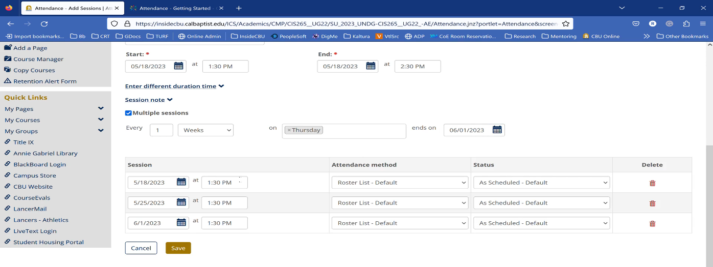

Manage a Session

- To delete a session, click the checkbox next to a session and click the Edit Button. Then on the next page, click Delete. (See Images 1 and 2 Below).
